**My Academy team at Cognizant want to create a dashboard containing the details of ongoing and completed cohorts. A react application is created which displays the detail of the cohorts using react component. You are assigned the task of styling these react components.**

**Directory:**

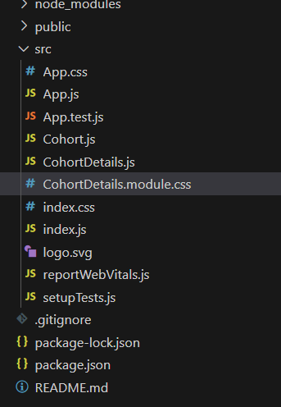

**Code for CohortDetails.module.css:**

.box{

    Width:300px;

    display:inline-block;

    margin: 10px;

    padding-left:20px;

    padding-right:20px;

    border: 1px solid black;

    border-radius: 10px;

}

.h3Green {

  color: green;

}

.h3Blue {

  color: blue;

}

 dt{

    font-weight: bold;

}

**Updated-Code for CohortDetails.js:**

import React from 'react';

import styles from './CohortDetails.module.css';

function CohortDetails(props) {

    const isOngoing = props.cohort.currentStatus === 'Ongoing';

    return (

        <div className={styles.box}>

           <h3 className={isOngoing ? styles.h3Green : styles.h3Blue}>

                {props.cohort.cohortCode} -

                <span>{props.cohort.technology}</span>

            </h3>

            <dl>

                <dt>Started On</dt>

                <dd>{props.cohort.startDate}</dd>

                <dt>Current Status</dt>

                <dd>{props.cohort.currentStatus}</dd>

                <dt>Coach</dt>

                <dd>{props.cohort.coachName}</dd>

                <dt>Trainer</dt>

                <dd>{props.cohort.trainerName}</dd>

            </dl>

        </div>

    );

}

export default CohortDetails;

**Output:**

